**Design Documentation: Helicopter Project Milestone 1**

**Group:**

**Nam Thach**

**Dylan Rush**

**Yachan Wang**

**Milestone 3 February 10th, 2014**

**Introduction**

In this final milestone we introduced new functionality towards the Term Project (Helicopter Project). This functionality include adding controls to change the bearing of the helicopter (able to rotate helicopter to any degree), added a help menu to show the user all of the controls for the helicopter, added a update text logger that shows the user up to date info of the helicopter positioning – speed – and forces, and more functionality.

**List of Extra Functionality:**

* Added help screen
* Added update logger to show helicopter
* Position (x,y,z)
* Velocity(m/s) (x,y,z)
* Forces in x and y lift in Z
* Orientation of the Helicopter (in degrees) – x, y, z
* Added functionality to rotate helicopter in any direction
* Added Logger Functionality – toggle
* Added a control to toggle friction on and off
* Alert user that helicopter has crashed because helicopter landed at a speed to fast 1.1 m/s
* Disabled the bouncing of the helicopter when it landed to hard
* Added ability to shoot missiles and added collision of missile to one of the blue balls

**Group Work**

The work of the project was split up accordingly:

Nam Thach:

* Hud application
* Helicopter orientation Function
* Logger active
* Friction toggle
* Added crash alert

Dylan Rush

* Added missile functionality
* Added collision detection

Yachan Wang

* Diagrams Update
* Hud functionality

**Current Status**

The current status of our project is that:

* While orientation of the Helicopter does work and the helicopter does rotate in all directions, there the controls control the helicopter as if it was in its normal position. In conclusion we can control the helicopter to move in anyway but it takes a bit of manipulating of controls as the user.
* The logger and help screen Perform to the correct specifications
* Crash alert works correctly but the helicopter still flies even if it has crashed, but the bouncing situation that happened before milestone 3 has been fixed.

**Design Diagrams**

Class Diagram

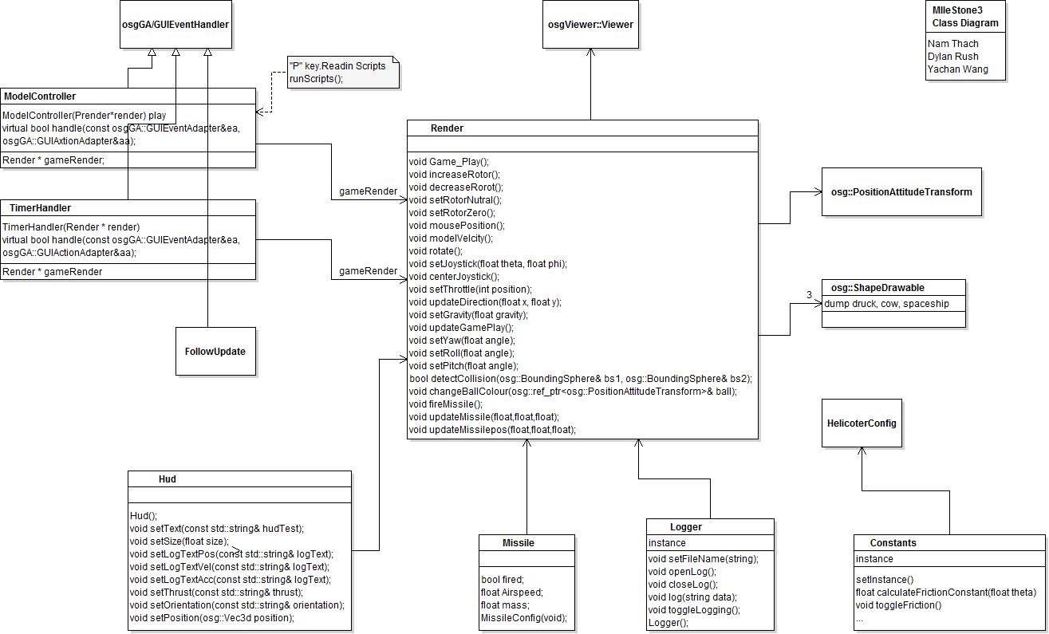

Sequence Diagram:

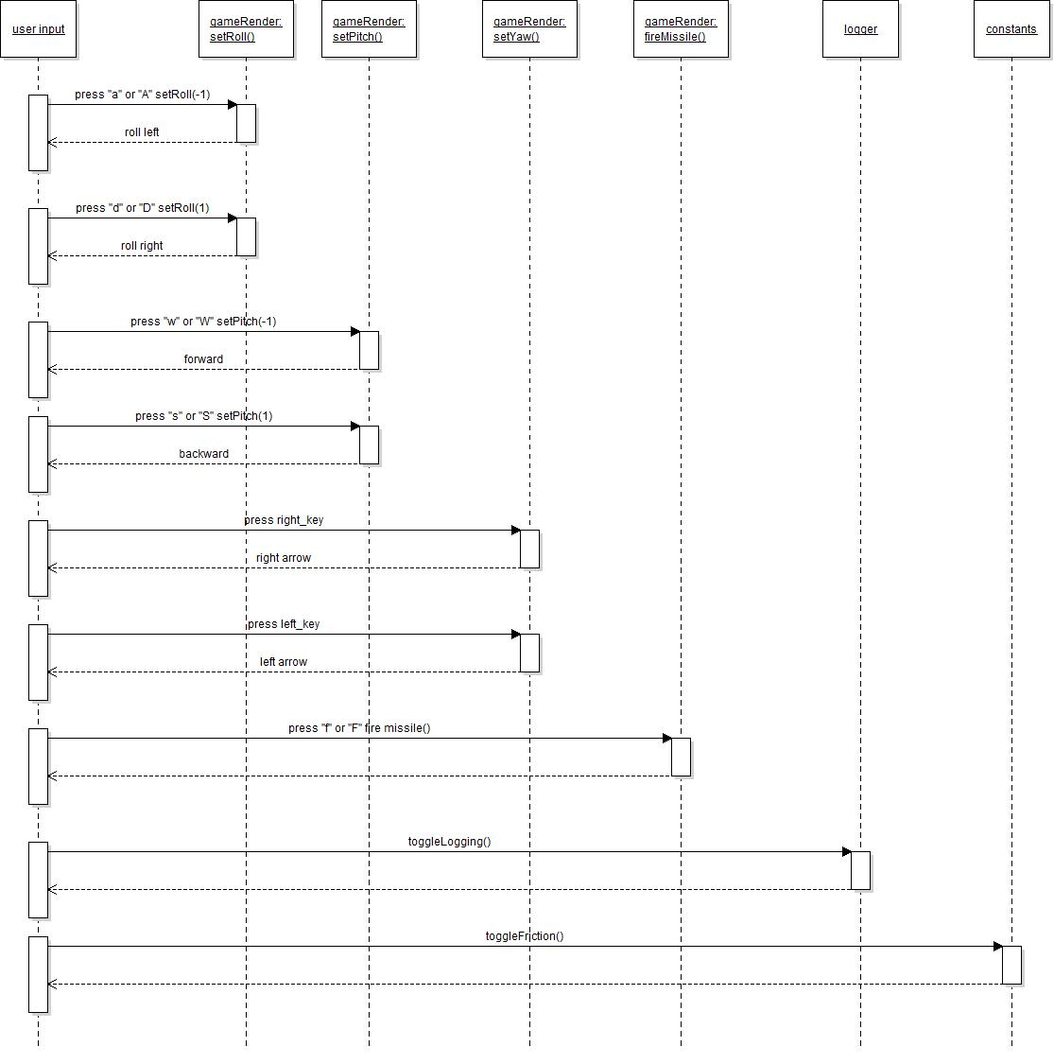

**Summary/Conclusion**

In conclusion working on this milestone first went rough as the updating hud logger had a few issues with working on different systems, but after some altering of the code we found that it was making a new text object every time the system would update causing a memory issue for some of the underperforming processing PC’s. After the changes the logger ceased to cause problems. The orientation of the Helicopter works as specified although the user has to manipulate the controls to make the helicopter control correctly when the orientation is changed from the starting position. As for our group, everyone chipped in with the project with choosing their own strengths to help complete the project. Our only downfall was that we ran out of time to work out the bugs of the program and add extra functionality. As well as one of our group members was not able to use GIT hub which limited the availability of coding.

Below are screen shots of the project in its updated state:

Main Shot of Helicopter Flying

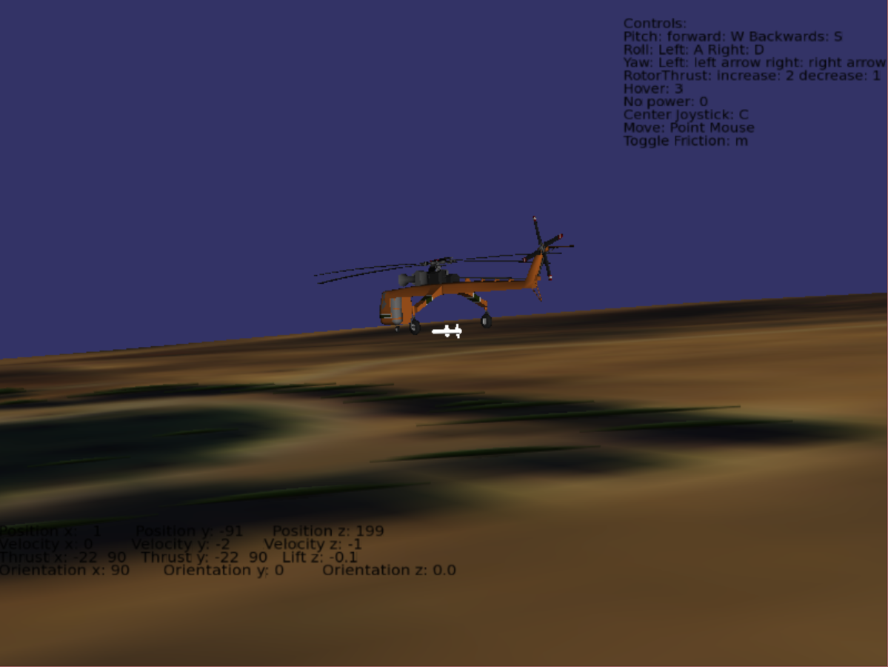

Helicopter from the Side

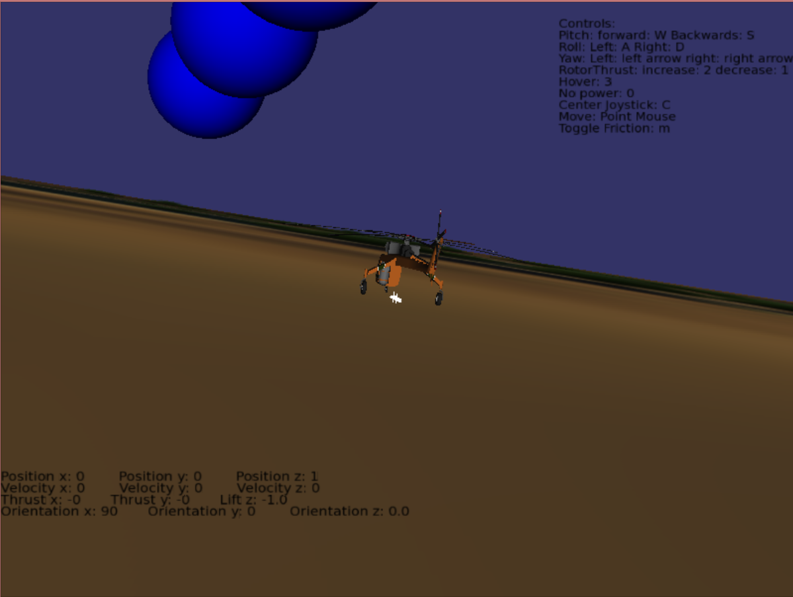

Missile Firing

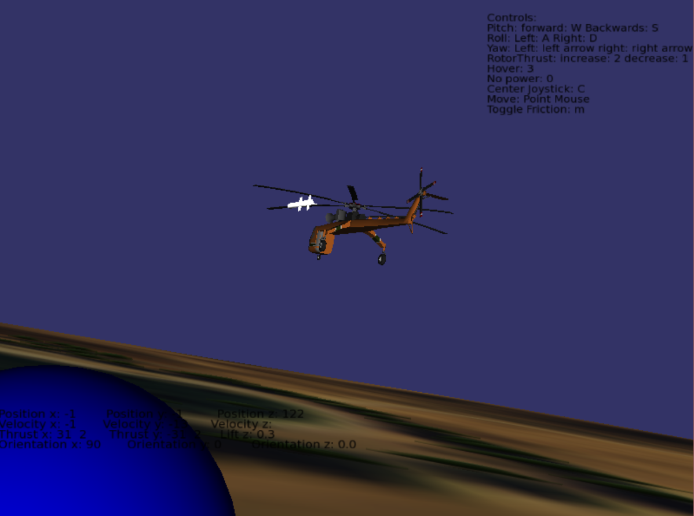

**GitHub Repository Link:**

<https://github.com/Nammy1101/Helicopter_Project.git>